Work Management System User Guide (for Students/Staff)

(Staff means persons who work for and receive salary from Waseda University as TA, RA, research assistant, and temporary staff.)　　　　　　　2013.08.29

From AY 2014, paper-based "time sheet" will be replaced to web-based report. Please fill your report according to the instruction below. Thanks to the digitization, you can confirm your salary detail online.

**To be changed as follows.**

**Paper-based time sheet**

**Web-based report**

**Web-based salary statement**

**You can refer to..**

# 1. Log In … Log in to the web system

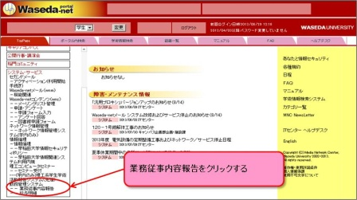For Waseda Students

Log in to Waseda-net portal, and click on "System Services" on the left menu and then click on "Report of Contents of Tasks Performed"

For Non-Waseda Students

1. Enter the user ID.

2. Enter the password.

Access <https://www.wpte.waseda.jp/wkmgt/wmgtServlet>. Enter your user ID and password indicated in the User Registration Report, and click on "Login" button.

Click on "Report of Contents of Tasks Performed".

3. Click on "Login" button.

* User Registration Report is issued and sent to you at the time when your employment contract is registered after submission of your employment application.

# 2. Contract Selection … Select the applicable contract for report entry

Search for the contract 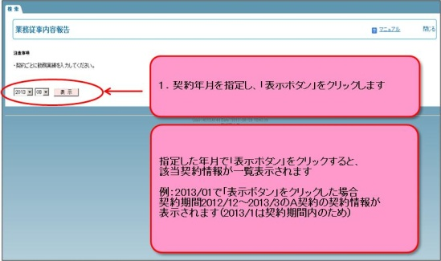by selecting the year/month.

List of your contracts for the period will be shown, so select the one to enter your working status.

Designate the contract month and click on "Display" button.

* Be sure to select the correct contract by confirming your position, affiliation, name of the research grants/course/part-time job, name of your manager, and contract period. **Filling the report of the wrong contract will cause some trouble (e.g. wrong salary calculation).**

When you click on "Display" button after selecting the month, you will find the list of your contracts for the period.

For example, when you select "2013/1" and click on "Display" button, Contract A with the period between December 2012 to March 2013 will be displayed as "2013/1" is included in the period.

* Not until your employment application is registered that you can enter your working data in the report. **Depending on the timing, there will be the case that you cannot select the contract even after you started working.** In that case, take notes of your working status, and enter the same later.

To go on to the next page, click on the link of the contract to which you want to enter the working data; any link in "Position", "Affiliation", "Research Grants/Course/Part-time Job", " Manager", "Contract Period", and "Contract No.".

# 3. Daily Entry of Your Working Status … Fill the report whenever you go to office.

After filling the columns, click on "Register" button.

3. Referring to the explanatory note above, tick the applicable one(s) for the 5) Descriptions of Jobs/Services Provided.

If you select "Z" (Others), describe the task in detail.

1. Enter the time on the applicable columns.

1) In, 2) Out, 3) Hours off Duty (break)

2. Enter the 4) Name of the Course. If multiple, separate by comma(s).

(Ex: Course A, B, C)

* This screenshot is for TA. Contents of the screen may differ depending on your position. Fill the report according to the items on the screen.

4. Click on "Register" button.

* There are the same button on the lower screen.

# 4. Approval … Manager will approve your report.

You do not need to do anything for approval. Notify your manager (if you are TA, notify your faculty member, etc.) that you have finished filling the report and have him/her approve your working status.

# 5. Modification of Working Status … In the case you made a wrong entry

■For working status yet to be approved, you can directly modify the entry from the screen of "Report of Contents of Tasks Performed". Re-enter the correct information and click on "Register" button.

■For working status already approved, you cannot directly modify the entry. Contact your manager and have him/her cancel the approval. Then, re-enter the correct information. The approval may not be cancelled. In that case, contact the office of your affiliation.

# 6. Salary Statement … You can confirm your salary on the screen

From the left menu of "Waseda-net portal" top page, click on "Salary Statement".

When you designate the date of salary payment, you will find the salary detail of the month. As the salary statement is updated around the date of salary payment, you may not be able to browse the latest statement depending on the period.

**Manual For the operation manual in detail, please refer to the upper right link on each screen or** [**http://www.wnpspt.waseda.jp/teacher/kinmu/**](http://www.wnpspt.waseda.jp/teacher/kinmu/)

**Point of Contact for System Operation**

**Email (for students/faculty members): Go to "IT Center-Help Desk" of Waseda-net portal.**

**Email (for others):**[**itc-support@list.waseda.jp**](mailto:itc-support@list.waseda.jp)

**Tel：03-5286-9845 　Academic Advising Office (Waseda Portal Office) Mon-Sat 9:00-18:00**

**Inquiry on other things related to work Please contact the office of your affiliation.**