**Joint Workshop Report**

Peter Chai (Kai Shibata), Doctoral Program, GSPS

Yinuo Wei, Master Program, GSPS

On February 10, 2025, a joint workshop was held in Room 302, Bldg. 26, providing the participants an opportunity of intercultural and inter-university academic exchange. Invited by Prof. Liang Tang from the Faculty of Political Science and Economics, Prof. Lu Zheng from the School of Social Sciences, Tsinghua University gave a presentation titled "A New Search for China's Local Governance: A Case Study of the Qinghe Road.” During the presentation, he gave a brief overview of the history of urban sociology in China and shared about a social experiment project his research team is undertaking focusing on a neighborhood in Beijing.

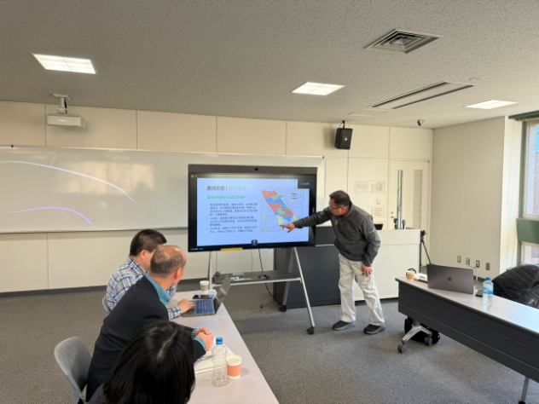

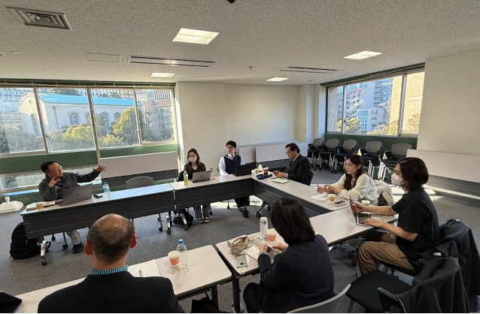

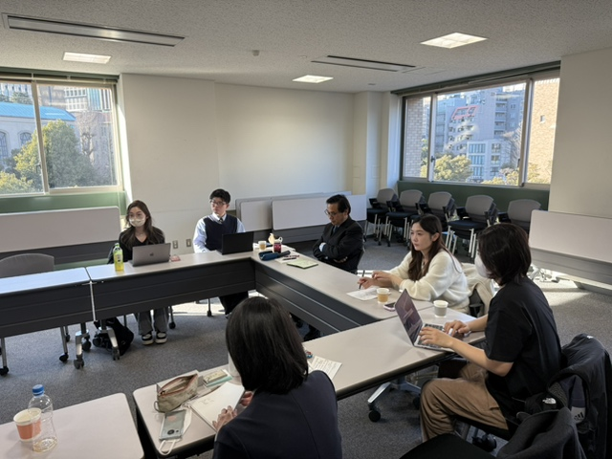

Following his presentation, Q&A and panel discussion sessions were held. In total, around 5 researchers from universities in China and Japan and around 10 graduate students from Waseda University joined the workshop. Topics on methodologies such as field research in the social sciences were discussed, and comparative perspectives were provided by the participants from different universities. The discussions showed how the combination of quantitative and qualitative, comparative and area studies, and empirical and historical approaches are needed to address multifaceted social issues and how the use of both survey data and social experiments are needed to analyze complex social realities.