To International Students with a foreign nationality

CIE Website for Status of Residence: <http://www.cie-waseda.jp/visastatus/en/index.html>

**Acquisition of Status of Residence of “Student”**

International students who are admitted to Waseda University are able to apply for a status of residence of “Student”. Those with the status of residence of “Student” are eligible to apply for tuition reduction/exemptions and scholarships for international students. **Be aware that those with a status of residence other than “Student” cannot use various services or systems intended for international students as stated above.**

**Please bear in mind that students are not eligible to enroll in the university with a “Temporary Visitor” status.** Carefully read (1)-(6) below and take the necessary measures to extend your period of stay, change your status of residence, request for application for COE by proxy, etc. **In order to go through the procedures concerning a status of residence, you will need to have made a second deposit.** If you need a “certificate of admission” for your application, ask the office of the undergraduate/graduate school you are scheduled to join to issue it after you have made your second deposit.

**(1) If you have a status of residence of “Student”**

If you currently have a status of residence of “Student,” please apply for “extension of period of stay” as necessary. You are able to apply for extension of period of stay from three months before your status of residence expires. For details on procedures, please refer to [“If your current status of residence is “Student””](http://www.cie-waseda.jp/visastatus/en/prospective/#section-2) in “For Prospective Students” on the above website.

**(2) If you have a status of residence of “Temporary Visitor”**

If you currently have a status of residence of “Temporary Visitor,” as a general rule, you will need to leave Japan once and apply for a status of residence of “Student.” For details on how to apply for a status of residence of “Student,” please refer to **“(4) If you do not have a status of residence.”**

**(3) If your status of residence is other than “Student” or “Temporary Visitor”**

If you finish the activity that falls under your current status of residence, you will need to change your status of residence to “Student.” If your status remains the same, such as “Dependent,” change the status of residence as necessary. For details on procedures, please refer to [“If your current status of residence is other than “Student””](http://www.cie-waseda.jp/visastatus/en/prospective/#section-3) in “For Prospective Students” on the above website.

【Note】In order to apply for extension of period of stay or change of status of residence, you need a completed application form issued by Waseda University. Prior to making the application to the Immigration Services Bureau, please submit the application form, a certificate of admission, and other necessary documents to the university.

**(4) If you do not have a status of residence**

In order to apply for a status of residence, you will first need to obtain a certificate of eligibility (COE) from the Immigration Services Bureau in Japan.Waseda University will apply for a COE on behalf of the applicant to the Immigration Services Bureau **only for international students residing outside Japan who have completed the enrollment procedures**. After a COE is issued and sent to Waseda University, it will be sent to you. Upon receiving the COE, you will need to take it with your passport to the Japanese embassy or consulate in your country of nationality/residence to apply for a “Student” visa. The COE is valid for 3 months after the issuance, so be sure to acquire your visa and enter Japan before the COE expires. Since it takes around two months for examination at the Immigration Services Bureau, please be careful not to start late with little time before enrollment.

【Note】

* **Waseda University will carry out the application by proxy only after you have made your second　deposit.** Please complete your payment as soon as possible, and start your procedures of requesting an application by proxy.
* For information on what documents are needed to request for application by proxy and where to send them, please see “Request for COE Application by Proxy” on page ○○.

**【Sequence of Steps Involved in Obtaining a “Student” Visa (①→⑦)】**

*Depending on the embassy/consulate, the duration before a “Student” visa is issued varies, and in some cases, it takes about 3 weeks.

*After submitting your application documents to Center for International Education, please contact the Japanese embassy/consulate which you intend to apply to and ask how long it will take for your visa to be issued.

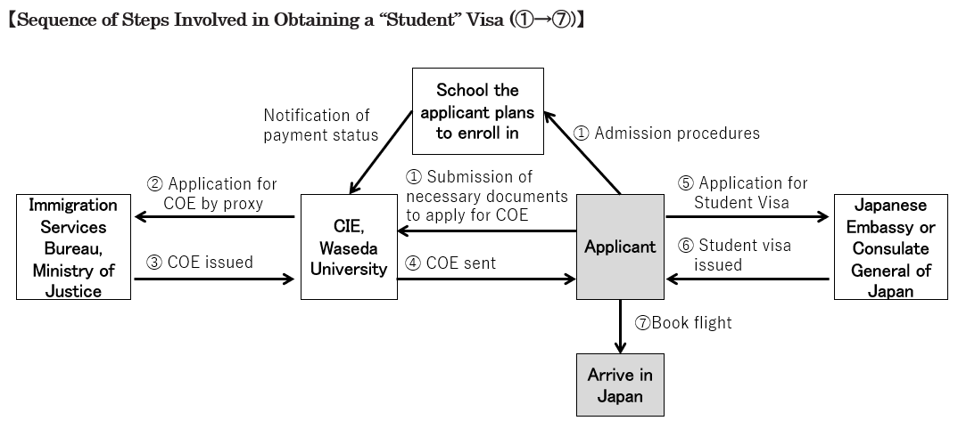

**(5) Acquisition/Change of status of residence**

**[Visa waiver or Temporary Visitor status holders]**

**If you enter Japan as a visa waiver or on a Temporary Visitor stauts (within 90 days of stay in Japan, for activities such as sightseeing, business, or visiting relatives, etc., that do not involve the receipt of money), in principle, you will need to leave Japan once to apply for a student visa by submitting your COE to the Japanese embassy or consulate in your country of nationality/residence.** However, if it is difficult for you to return to your home country before the start of the new semester because of the late issuance of the COE due to the entrance exam held at the end of the academic year (end of February/March), you can apply for change of status of residence at the Immigration Services Bureau upon issuance of a COE. However, please bear in mind that this application is unusual, and that you may not be allowed to change the status of residence. As the Immigration Services Bureau is solely responsible for decisions regarding the status of residence, Waseda University cannot be held responsible for the duration of screening or outcome.

【Note】 **For holders of a temporary visitor status of 30 days or less, change of status in Japan is not allowed. Please leave Japan once**, submit the COE at the Japanese embassy or consulate in your country of nationality or residence, and obtain a student visa before re-entering Japan.

**(6) Other important points**

* The Center for International Education, Waseda University acts on your behalf to apply for a “Student” status of residence only. If you wish to apply for other types of status of residence, you need to make an application by yourself at the Immigration Services Bureau.
* The Immigration Services Bureau may require you to submit additional documents if needed.
* If you decide not to enter Waseda University, please immediately inform the Center for International Education. Also, if you are accepted by another university in Japan, please make sure that you do not apply for a COE through more than one university. If there are multiple applications, a COE cannot be issued.
* If you have multiple nationalities including a Japanese nationality, you are not eligible to apply for a COE.
* The Immigration Services Bureau is solely responsible for decisions regarding the status of residence. If issuance is delayed or application is not approved, Waseda University cannot be held responsible for the cancellation fee of your air ticket or other inconveniences. Please be careful when you book your flight.
* For application procedures concerning “Student” status of residence, please contact the Center for International Education, Waseda University (e-mail：cie-zairyu@list.waseda.jp).

**<Request for COE Application by Proxy>**

**◎**Make sure to send all the necessary documents below to the Center for International Education (CIE) by registered post (Express Mail Services, etc.).

**【Necessary Documents for COE Application by Proxy】** *Put a check mark☑ for each document you enclose in the package.

□ ①[Application For Certificate of Eligibility](http://www.cie-waseda.jp/visastatus/en/pdf/COE.pdf) (3 pages & 1 ID photo taken within the past 6 months)

＊Be sure to check the [Entry example](http://www.cie-waseda.jp/visastatus/en/pdf/COE_sample_en.pdf).

□ ②Copy of Passport (Page with your photo)

□ ③[Written Oath for Defraying Expenses](http://www.cie-waseda.jp/visastatus/en/pdf/5keihisibensho.pdf) (if someone besides yourself is covering your expenses)

□ ④Documents Concerning Defraying Expenses

|  |  |  |
| --- | --- | --- |
| 1 | You are financing yourself | Bank Balance Certificate*1) (account in your name) |
| 2 | You are going to receive scholarship | Certificate of Scholarship *2) |
| 3 | Someone besides yourself is covering your expenses | Bank Balance Certificate*1) (account in the name of the person covering your expenses) and Written Oath for Defraying Expenses |

*1) Bank Balance Certificate: It must show the name of the account holder, name of bank, date of issue, and account balance.

・Rough estimate of the amount in the bank balance: At least the total amount of tuition fee and living expenses for half a year must be met. (If the account balance is in a currency other than Japanese yen, CIE will convert it by using the exchange rate at the time your documents are being checked.)

･Living expenses (including housing costs): approx. 120,000 yen per month

･Tuition fee: Varies depending on your undergraduate/graduate school

・If it is written in a language other than Japanese or English, attach a Japanese or English translation. (notarization is not needed)

*2) Certificate of Scholarship:

If the monthly amount of the scholarship is less than the total amount of living expenses and tuition fee per month, please also submit another statement on source of funds including a bank balance certificate, as evidence that the shortfall can be compensated.

□ ⑤Request for COE Application by Proxy Form (this sheet)

□ ⑥If it has been more than 5 years since you graduated from your last school at the time of admission to Waseda University, the following documents are required:

1. Resume (no designated format, but use an A4 size paper, including your background and reasons for your studies)

2. Document explaining your future plans (no designated format, but use an A4 size paper, including your plans after graduation)

*Examination for COE applications takes two to three months, so regardless of the deadline, we strongly recommend that you remit the entrance fee/tuition swiftly, and make your application early.

Mailing Address Contact  
“COE Application by Proxy” Section, 　 E-mail：cie-zairyu@list.waseda.jp

Center for International Education, Waseda University

1-7-14-4F Nishi-Waseda, Shinjuku-ku, Tokyo 169-0051, Japan

[Phone: 03-3203-9806](TEL:03-3207-1454)

|  |  |
| --- | --- |
| Name in English alphabet |  |
| Address in English alphabet |  |
| Phone Number |  |
| E-mail address | A COE is issued electronically and sent via email. Be sure to inform us of any change immediately. |
| School in Waseda University to be enrolled |  |
| Examinee’s Number |  |