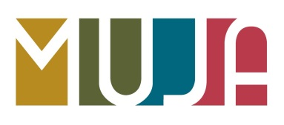
×WASEDA
McCann Erickson TOKYO
INTERNSHIP PROGRAM
Application Guideline

Internship Period：Monday, August 5th ～ Friday, August 16th 2019
Eligibility：
・Regular undergraduate/graduate students at Waseda University
*Undergraduate students must be 2nd year or above
・Fluent in Japanese and familiar with Japanese culture/society
*You are expected to provide a “local” perspective during group work discussions)
・High level of English proficiency
*The interview, group work, field work, and presentation will be conducted in English
・Interest in marketing and advertisement

Available positions：10
Application period：Between Friday, April 19th 10:00 and Wednesday, May 8th 17:00
Application and Selection：
- Apply using the Online Application Form.

- After an initial selection, a skype interview will be conducted with the program coordinator at University of Missouri
Interview date: Wednesday, 29th or Thursday, 30th (either one of the days)
※Only successful applicants for the document screening will be contacted individually by May 20th.

