<MBA Degree Thesis>
AY 20xx

Enter Your Title of MBA Degree Thesis Here
Enter sub title here

57xxxxxx Enter your Full name
Enter your Zemi Title
C.E. Prof. King of Waseda
D.E. Prof. Queen of Waseda D.E. Prof. Junior of Waseda

Summary

This is an example style of the summary of MBA degree thesis of Graduate School of Business and Finance. The summary is one to three pages. Default font is Times New Roman 10.5pt. First line is main title of your thesis. It is 20pt, capital letters, centering. Next item is sub title. It is optional, so you can delete second line, font size is 18pt and centering it. Next line is your student ID number and your full name. Next line is your zemi title. Next line is your Chief Examiner’s name. Next line is your Deputy Examiners. After Deputy Examiners line, body is started. The body contains purpose of your thesis and main results. Text number of word is about 500 words per page. You can include the pictures/tables of main results.
After this paragraph, it is loop of previous one for filling this summary template file. This is an example style of the summary of MBA degree thesis of Graduate School of Business and Finance. The summary is one to three pages. Default font is Times New Roman 10.5pt. First line is main title of your thesis. It is 20pt, capital letters, centering. Next item is sub title. It is optional, so you can delete second line, font size is 18pt and centering it. Next line is your student ID number and your full name. Next line is your zemi title. Next line is your Chief Examiner’s name. Next line is your Deputy Examiners. After Deputy Examiners line, body is started. The body contains purpose of your thesis and main results. Text number of word is about 500 words per page. You can include the pictures/tables of main results.
This is an example style of the summary of MBA degree thesis of Graduate School of Business and Finance. The summary is one to three pages. Default font is Times New Roman 10.5pt. First line is main title of your thesis. It is 20pt, capital letters, centering. Next item is sub title. It is optional, so you can delete second line, font size is 18pt and centering it. Next line is your student ID number and your full name. Next line is your zemi title. Next line is your Chief Examiner’s name. Next line is your Deputy Examiners. After Deputy Examiners line, body is started. The body contains purpose of your thesis and main results. Text number of word is about 500 words per page. You can include the pictures/tables of main results.
This is an example style of the summary of MBA degree thesis of Graduate School of Business and Finance. The summary is one to three pages. Default font is Times New Roman 10.5pt. First line is main title of your thesis. It is 20pt, capital letters, centering. Next item is sub title. It is optional, so you can delete second line, font size is 18pt and centering it. Next line is your student ID number and your full name. Next line is your zemi title. Next line is your Chief Examiner’s name. Next line is your Deputy Examiners. After Deputy Examiners line, body is started. The body contains purpose of your thesis and main results. Text number of word is about 500 words per page. You can include the pictures/tables of main results.
This is an example style of the summary of MBA degree thesis of Graduate School of Business and Finance. The summary is one to three pages. Default font is Times New Roman 10.5pt. First line is main title of your thesis. It is 20pt, capital letters, centering. Next item is sub title. It is optional, so you can delete second line, font size is 18pt and centering it. Next line is your student ID number and your full name. Next line is your zemi title. Next line is your Chief Examiner’s name. Next line is your Deputy Examiners. After Deputy Examiners line, body is started. The body contains purpose of your thesis and main results. Text number of word is about 500 words per page. You can include the pictures/tables of main results.
This is an example style of the summary of MBA degree thesis of Graduate School of Business and Finance. The summary is one to three pages. Default font is Times New Roman 10.5pt. First line is main title of your thesis. It is 20pt, capital letters, centering. Next item is sub title. It is optional, so you can delete second line, font size is 18pt and centering it. Next line is your student ID number and your full name. Next line is your zemi title. Next line is your Chief Examiner’s name.
<Inside Cover>

Enter Your Title of MBA Degree Thesis Here
Enter sub title here

57xxxxxx Enter your Full name
Enter your Zemi Title
C.E. Prof. King of Waseda
D.E. Prof. Queen of Waseda D.E. Prof. Junior of Waseda
Table of Contents
After deciding headings and write it, then applying "Heading1-3" style on it, then make a Table of Contents here as following steps:
1. Click on the menu of "Insert" (Microsoft Word 2000).
2. Select "Index and Tables..." then click on the tab of "Table of Contents”.
3. Click on OK button. Then appear Table of Contents.
Section numbers are automatically added by the “Heading 1-3 style”.
Chapter 1. Introduction and submitted materials 1
Section 1. Status of This Document 1
Section 2. Master Thesis of Electrical Version 1
Chapter 2. Document Style and Format 2
Section 1. Base Setting 2
Section 2. Figures and Tables 2
Section 3. Footnotes 4
Section 4. Styles 4
References (This is a Sample) 5

If you want to update the table of contents (page number and headings), click on the left button on the item of contents, then select “Update Fields”.

Introduction and submitted materials

Status of This Document
This document is a recommended format and a sample of the 2003 YR(graduated 2003 September, and 2004 March) of Master Thesis of Graduate School of Asia and Pacific Studies. This format is written by Microsoft Word 2000 (later version or compatible format may be OK), but you can use other word processing software if and only if you are able to create thesis of PDF version in your personal computer environment and make it as same as this format by yourself. If you are converting from your software format into PDF file, you should include all font information in the PDF.

Master Thesis of Electrical Version
Electrical version of Master thesis and summary are absolutely prepared and are complied with the following rules.
- DOC (Microsoft Word) or PDF (Adobe Acrobat) are available file type.
- File name is your student ID. <Ex. K00X001.DOC or K00X001.PDF>
- File name of summary is added "-S" to your ID. <EX. : K00X001-S.DOC>
- You need to store your own backup files of thesis and its summary.
- If you created by using the other computer environment (Macintosh, Linux or LaTeX, Lotus Word etc.), you should save a plain text file(name as student_id.txt) into submitted media with detail of your computer environment (Operating System, Word processing software, Software Vender name, Software versions, etc…).

Document Style and Format
You can use some styles defined in this template file. You can change these styles but NOT to change the following 3 styles:
- Paper size and page margins.
- Column and line spacing.
- Default text font and font size.

Base Setting
Paper size: A4. Orientation: Portrait. Printing: One side. Top margin: 35mm, the other margins are 30mm, Header from edge: 15mm, footer from edge: 17.5mm. There settings are default setting of Microsoft Word2000. You can check these parameters in the "page setup…" on the file menu (Figure. 1 and Figure. 2). Default page style is one column. Line spacing is double. Default page font is Times New Roman 10.5pt.

Figure. 1: Page margins. | Figure. 2: Page size.
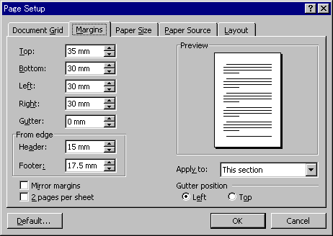 | 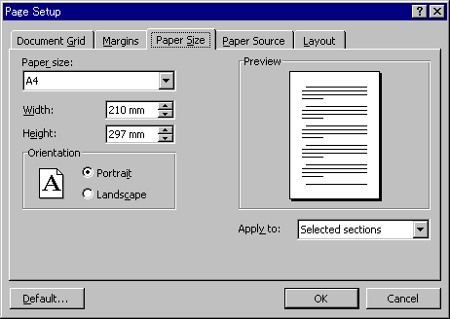
Source: MSWord2000 EN Screenshot | Source: MSWord2000 EN Screenshot

Figures and Tables
The format of picture should be setup that layout is “In line with text”. It is NOT recommended that layout setting is “Square”, “Tight”, “Behind Text”, “Front Text”. This setting can be change in the following steps:
- Click right button of mouse on the target picture.
- Select “Format Picture…”
- Click on the tag of “layout”
- Choose “In line with text” (Figure 3).
I think you need to adjust size of picture into the text area. If you want to insert two or more pictures in one page, pictures can align by using table function (e.g. Figure. 1 and Figure. 2). But single picture/table is recommended for using cross-references (Figure. 1 and Figure. 2 are manual setting, because of there are in the table, Figure 3 is automatically generated.). Picture/Table needs a caption which can include from ”Insert” > “Captions…”. These number are managed by Microsoft Word, and you can refer the number by using “Insert” > “Cross References…”.
You can paste a graph/table of Microsoft Excel by copying on the graph of Excel application. Any standard objects of Microsoft Office application is O.K. But, if you want to use a special application for drawing pictures or tables, please check by yourself that your picture can visible and printable on GSAPS computer environment.
Figure 3 : Standard Layout “In line with text”
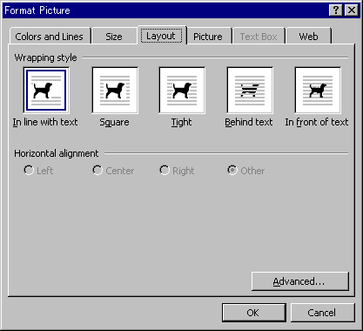
Source: Microsoft Word 2000 EN

Footnotes
There are two type of footnote. One is “Foot note”. Another is “End note”. We usually use “End note”, but please ask style to your coordinator/supervisor. If you want to put the footnote at the end of section or chapter, please proceed on the following steps:
- From the menu of “Insert”, select “Footnote…”
- Push on the button “Options…”
- Change from “End of document” to “End of section” at the selector of “Place at”
- Insert “section break” before all Heading 1. “Section break” can insert from the menu of “Insert” > ”Break…” > ”Continuous”. If you want to see the “Section break” on your display, “Tools” > ”Options” > ”View” Tag > Check “all” in the “formatting marks”

Styles
Some basic styles in this template file are listed bellow:
Style name | Format Detail
1. HEADING1 | Bold, 14pt, Page break before, Flush left, Space after 1.5 line. Outline level 1
1.1. Heading2 | 12pt, Small caps, Space before 1 line after 1 line, Outline level 2
1.1.1. Heading3 | 11pt, Space before half line after half line, Outline level 3
Body text | Times New Roman 10.5pt, double spacing, Indent First 6 characters
Caption | Bold, Flush left, Space before 1 line, Keep with next
Figure or Table Body | Centering, Keep with next
Figure or Table Footer | Flush right, Space after 0.5 line, Not keep with next
References | Same as Heading 1 except numbered
[1] Reference Items | Numbered
Appendix | Same as Heading 1 except numbered

You can customize these style format from the menu of ”Format” > ”Style…” > Select style name > ”Modify…” > ”Format”. But, do not too adhere to this style. Simple is better.
References (This is a Sample)
- Inoue, T. (2001). “Symbolic Computation for Asymptotic Expansions of Multivariate Statistics”, in Japanese (to appear).
- Inoue T., Asahi Y., Yamaguchi K. (2001). “An Advanced Statistical Information Disclosure over the Internet”, Proceedings of the IAOS Satellite Meeting on Statistics for the Information Society, 208-217.
- Inoue T., Iwashita T. and Niki N. (1998). “Matrix Differential Operations for Obtaining Asymptotic Expansions for the Distribution of Multivariate Statistics”. 3rd Conference on Statistical Computing of the Asian Regional Section, Conference Papers, 381 – 390.
- Okada, A. (1998). “Effects of end-aisle display and flier on the brand-switching of instant coffee”. In C. Hayashi, N. Ohsumi, K. Yajima, Y. Tanaka, H. H. Bock, & Y. Baba (Eds.), Data science, classification, and related methods (pp. 716-727). Tokyo: Springer-Verlag.
- Takeuchi, K., Yanai, H., & Mukherjeee, B.N. (1982). “The foundation of multivariate analysis”. New Delhi: Wiley Eastern.

