WH format (ver. 1)

**Instruction for Typesetting Manuscripts for WaISES 2014**

First AUTHOR, Second AUTHOR and Third AUTHOR

*Affiliation*

(Received Mmm. dd, yyyy. This date will be inserted by editors.)

The abstract should summarize the context, content and conclusions of the paper in less than 200 words. It should not contain any references or displayed equations. Typeset the abstract in 8 pt roman, making an indentation on the left and right margins. For the title, try not to use more than 3 lines. Typeset the title in 10 pt boldface roman. Typeset names in 9 pt roman, uppercase for family names. Affiliation should be 9 pt italic.

Keywords: Keyword1, Keyword2, Keyword3 (8pt Calibri).

**1. Introduction**

Usually the thesis is started by “Introduction”. This section should include the introduction of the research, that is, necessary information for readers to understand the paper. Preceding studies or relating studies are written here, using references. The importance of the study is also written here. Finally, the structure of the thesis is explained.

**2. The Main Text**

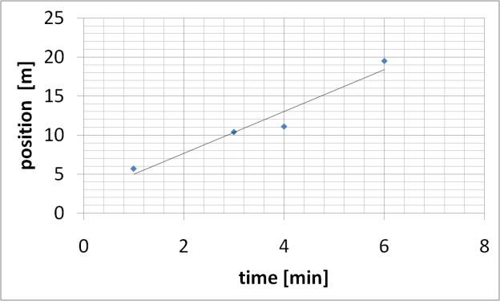 Authors are encouraged to have their contribution checked for grammar. American spelling should be used. Abbreviations are allowed but should be spelt out in full when first used. Integers ten and below are to be spelt out. Italicize the other language phrases (e.g. Latin, French).

The text is to be typeset in 9 pt roman. The major headings should be written in 9 pt bold roman with the first letter of important words capitalized.

**2.1 *Sub-headings***

Sub-headings should be typeset in boldface italic and capitalize the first letter of the first word only. Section number is to be in boldface roman.

2.1.1 *Sub-subheadings*

Typeset sub-subheadings in medium face italic and capitalize the first letter of the first word only. Section numbers to be in roman.

**2.2 *Numbering***

Sections, sub-sections and sub-subsections are numbered in Arabic. Use spacing before all section headings.

**3. Equations**

Displayed equations should be numbered consecutively, with the number set flush right and enclosed in parentheses. The equation numbers should be consecutive within each section. Thus the equations in Sec. 3 would be labeled (3.1), (3.2), etc.

 . (3.1)

Equations should be referred to in abbreviated form, e.g.“Eq. (3.1)” or “Eq. (3.2). ”

**4. Illustrations and Photographs**

Figures are to be inserted in the text nearest their first reference. Figure placements can be either top or bottom. If photographs are to be used, only black or white ones are acceptable.

Figures are to be sequentially numbered in Arabic numerals. The caption must be placed below the figure. Typeset in 8 pt roman. Long captions are to be justified by the “page-width”.

Fig. 1. The relation between time and position of the object. The real line is the approximated line.

**5. Tables**

Tables should be inserted in the text as close to the point of reference as possible. Some space should be left above and below the table.

Tables should be numbered sequentially in the text in Arabic numerals. Captions are to be centralized above the tables. Typeset captions in 8 pt roman. Long captions are to be justified by the “table-width”.

Table 1. Comparison of the position of the Object 1

and 2.

**6. Footnotes**

Footnotes should be numbered sequentially in superscript Arabic numerals[1].

**Acknowledgments**

This section should come before the References. Funding information may also be included here. For this Instruction, “Instruction for Typesetting Manuscripts using TeX or LaTeX ” for Reviews in Mathematical Physics [3] is referenced. The instruction of this journal is greatly acknowledged.

**Appendix A. Appendices**

Appendices should be used only when absolutely necessary. They should come before the References.

**References**

References are to be listed in order cited in the text in Arabic numerals. They can be typed after punctuation marks, e.g. “ ... in the statement [5].” or used directly, e.g. “see [5] for examples.” Please list using the style shown in the following examples. For journal names, use the standard abbreviations. Typeset references in 9 pt roman.

**References**

[1] S. Sorenson, *HOW TO WRITE Research Papers* (Macmillan Reference, USA, 1998).

[2] Y. Nambu and G. Jona-Lasinio, Physical Review **122**, 345-358 (1961).

[3] The Website of “Reviews in Mathematical Physics”, http://www.worldscientific.com/worldscinet/rmp

1. Footnotes should be typeset in 8 pt roman at the bottom of the page.