Information about the Interview Location (Frankfurt)

Interview Location:
KDDI Deutschland GmbH Frankfurt Branch
Kleyerstrasse 79-89, 60326 Frankfurt am Main, Germany

Meet at:
“Building C2” at KDDI Deutschland GmbH Frankfurt Branch
Note:
1. Make sure to bring your photo ID such as passport.
2. Present your photo ID at reception.

Contact:
International Admissions Office, Waseda University
TEL: +81-3-3204-9072
E-mail: iao-gs@list.waseda.jp

MAP1
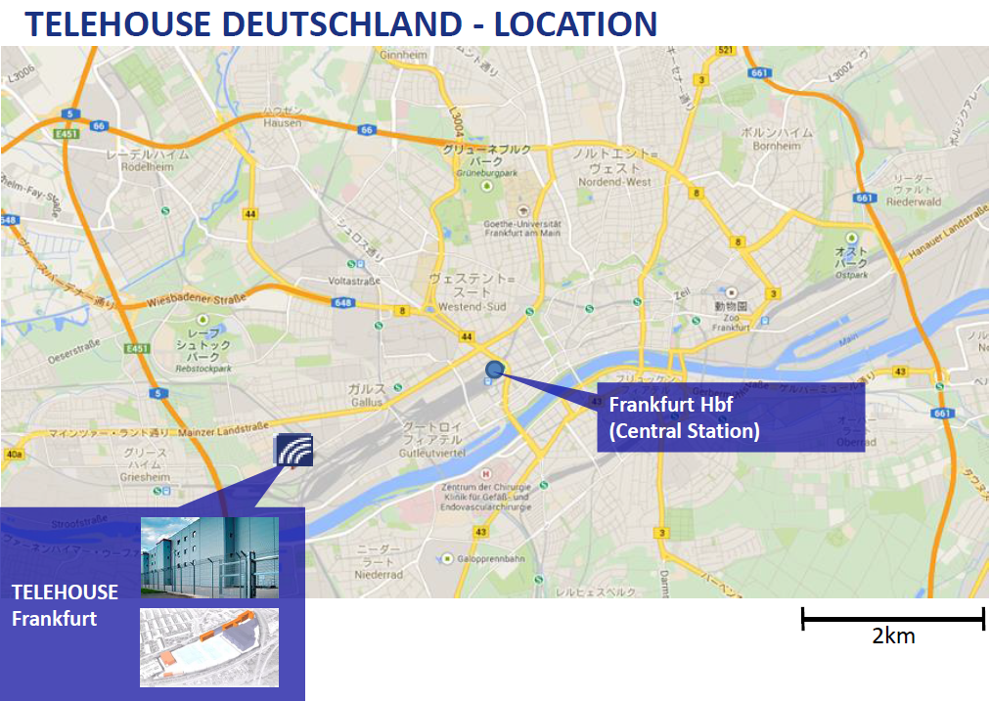
MAP2
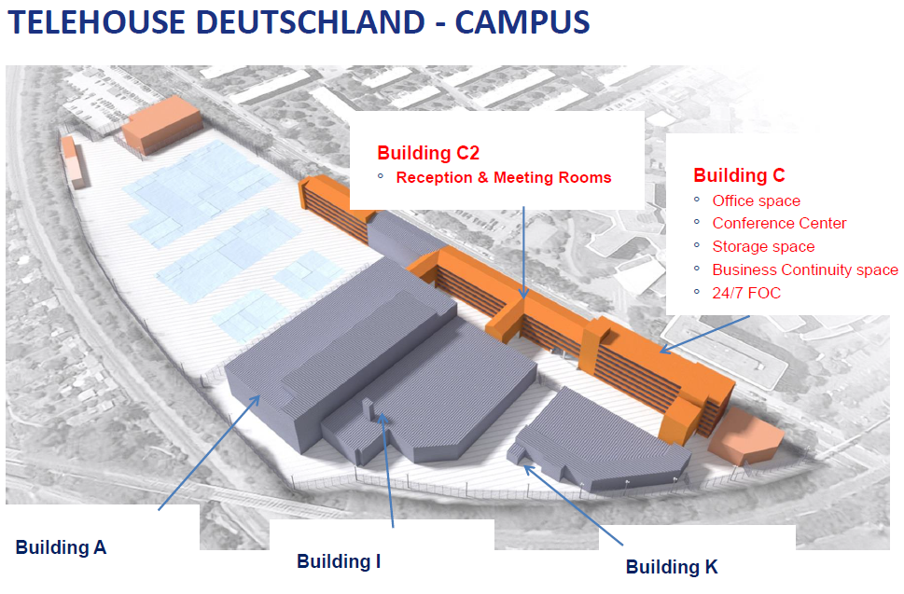
HERE

