Information about the Interview Location (San Francisco)
Interview Location:
Waseda USA San Francisco Office
44 Montgomery Street, Suite 2440,(24th Floor)
San Francisco, CA 94104
Tel: +1-415-693-9286
Fax: +1-415-693-9287

Contact Prior to the Interview:
International Admissions Office, Waseda University
TEL: +81-3-3204-9073
E-mail: iao-gs@list.waseda.jp
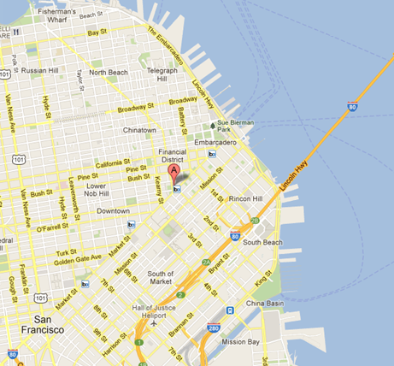
MAP

