Information about the Interview Location (Shanghai)

Meeting Place:
1st Floor (Lobby), No. B, W Square, 1686, Wuzhong Rd, Minhang District,
Shanghai
上海市闵行区吴中路1686号 W广场B栋1楼大堂

Contact Prior to the Interview:
(China) Waseda University Shanghai Education Research Center
Room 207, No. B, W Square, 1686, Wuzhong Rd, Minhang District, Shanghai
上海市闵行区吴中路1686号 W广场B栋207室
Tel: +86-21-6510-0099 / E-mail: iao-china@list.waseda.jp

(Japan) International Admissions Office, Waseda University
Tel: +81-3-3204-9073 / E-mail: iao-gs@list.waseda.jp

MAP 1
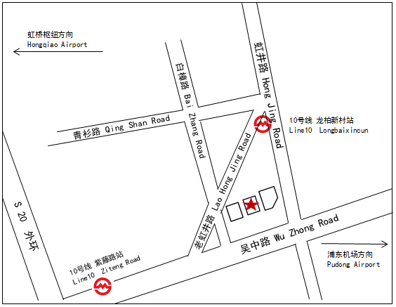
SEE REVERSE ⇒

MAP 2
